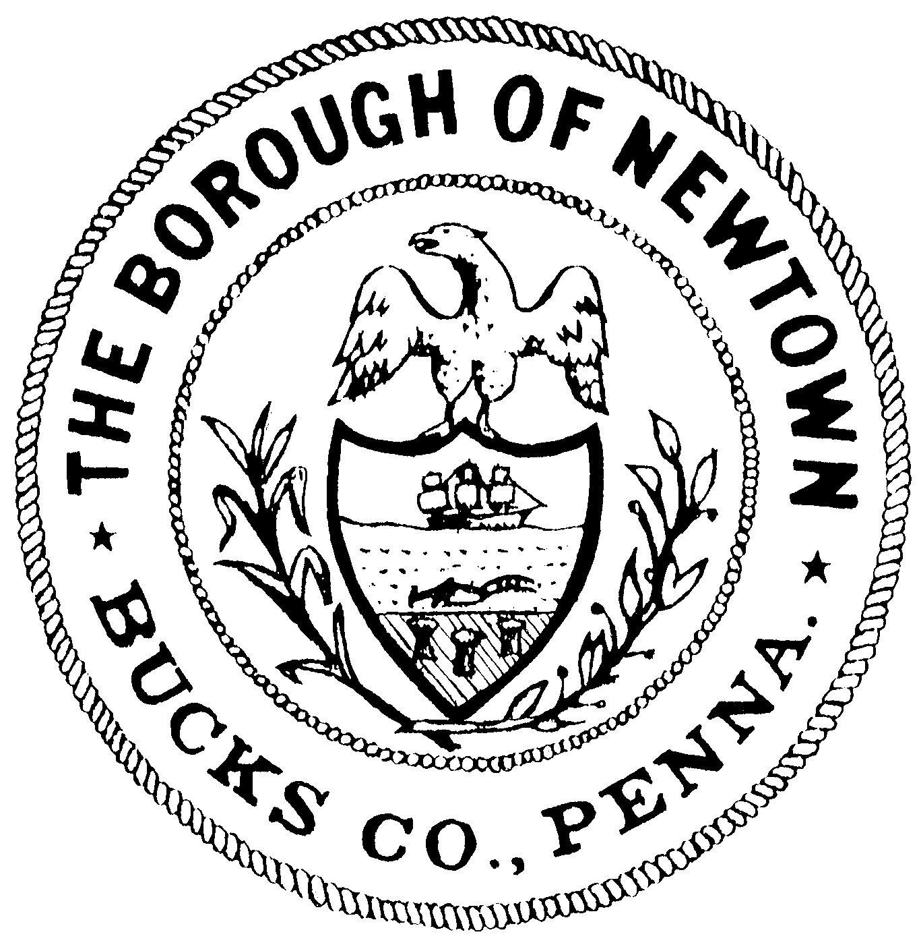
The Borough of Newtown Historical Architectural Review Board

CERTIFICATE OF APPROPRIATENESS APPLICATION

WHY THE HARB?
The Borough of Newtown established the HARB as a public, community advisory body to protect and preserve the cultural, historical, and architectural character of the Historic District [the District]. This preservation involves responsible stewardship, use and management of historic properties as a way to protect them for future generations. This is best achieved by maintaining the features which define the character of individual historic buildings. When individual historic properties and resources are appropriately maintained, the historic district is also preserved.
The Historic District Ordinance and the Department of the Interior (DOI) Standards for the Treatment of Historic Properties are the basis for the HARB’s review of Certificate of Appropriateness (COA) applications. The DOI standards were developed by the National Park Service. A complete copy of the DOI standards can be found at www.nps.gov and on the Borough website (www.boroughofnewtown.com). The standards most commonly applicable are those for Rehabilitation—see Preservation Terminology and Summary of DOI Standards for Rehabilitation on page 3. The Borough website also has HARB’s guidelines for Roofing, Sign & Awnings, and Wood Windows, as well as a matrix of construction materials for various project types.
The members of the HARB include a registered architect, a real estate broker, the Building Inspector, and other Borough residents.
WHAT THE HARB REVIEWS
When a COA application is scheduled for HARB review, this will include all proposed exterior changes to buildings and structures within the District which are visible from a public street, sidewalk, or right-of-way. The HARB reviews each COA proposal to determine whether it is appropriate to the individual property and to the District as a whole regarding the architectural style, general design, details, location, and materials.
Work reviewed by the HARB includes, but is not limited to:
- Adaptive reuse
- Addition
- Alteration
- Building relocation
- Demolition (after review by the Joint Historic Commission (JHC))
- Fences, walls, garden structures
- New construction
- Repair not in-kind
- Replace with new
- Signs and awnings
- Lighting fixtures and hardware
WHAT THE HARB DOES NOT REVIEW
The HARB does not review:
- any interior changes
- colors for any project
- driveways or landscaping
- replacements-in-kind (see Terminology section, below). Financials, maintenance, or energy conservation are not considered
REQUIRED INFORMATION AND DOCUMENTATION
The HARB must have all required information and documents to review an application for a COA. If all required information is not submitted, the application may be tabled or denied. Please note that all design and construction details must appear on the scaled drawings, as these are the field documents that will be referenced during construction.
The following are required for all applications:
- Completed COA application
- For demolitions, partial or total, a Determination of Significance (DOS) from the JHC
- Labeled photographs showing all public views of buildings or structures included in this application
- Detailed photographs of the areas that will be impacted by the proposed work
- Catalog cuts of materials to be used
The following additional documents are required for all applications excluding Repairs and Signs and Awnings:
- Scaled drawings indicating all proposed changes and notations for all materials and architectural details
- Site plan including immediately adjacent sites
- All impacted elevations
- Details of new exterior design elements, materials, and dimensions
The following additional documents are required for Signs and Awnings:
- Labeled photographs showing all public views of sides of existing and adjoining buildings
- Scaled drawings:
- Façade elevation or sketch of proposed sign or awning to provide scale
- Elevation of sign or awning with letter size, style, logo, and layout
- Detail of attachment to building
- Detail of illumination, if applicable
- Detail of edge treatment, if exposed
PRIOR TO COA APPLICATION SUBMISSION
HARB welcomes the opportunity to provide feedback early in the design process, and pre-application reviews are encouraged. Preliminary ideas, descriptions, photographs, and sketches can be discussed and feedback given early in the process, pre-application.
REVIEW PROCESS AND SCHEDULE
COA applications must be submitted with all required information a minimum of thirty (30) days prior to the HARB meeting at which the application will be reviewed. The Zoning Officer will review the application to confirm that all required information is included, that any demolition work has been reviewed by the JHC, and that the proposed work complies with all Borough codes. COA applications will only be scheduled for review by the HARB after all zoning issues have been resolved and JHC review for demolition, if applicable, is complete.
The applicant or a project representative is strongly encouraged to attend the HARB meeting to any answer questions or provide additional information. If the HARB has questions and the applicant is not in attendance, the application will be tabled until the necessary information is provided by the applicant.
At the meeting, the HARB will take one of the following three actions:
- table the application pending additional needed information
- recommend the application be approved, with or without conditions, or
- recommend the application be denied

Please note that it is common for the HARB process to take multiple meetings.

The HARB’s recommendation will be heard as an agenda item at the next scheduled regular Borough Council meeting.
Please note that the HARB review is necessary but not sufficient for granting of a building permit. Each demolition project is subject to prior review by the Joint Historic Commission (JHC). Every project is subject to review for compliance with zoning and building code ordinances prior to HARB review. Once the HARB reviews proposed changes for appropriateness within the District, it will make a recommendation to Borough Council to approve or deny the COA. Every project is subject to final approval by Borough Council.
If approved by Borough Council, the COA Administrator will issue a COA specifying all conditions to be met. The applicant may then apply for all required permits.
HARB meetings typically occur the fourth Wednesday of every month; in November and December, they occur on the third Wednesday of the month. Council meetings are typically held at 7 p.m. on the second Tuesday of the following month; applicant attendance at this meeting is highly recommended. The dates of the next meetings can be confirmed by checking the meeting calendar on the Borough website (www.boroughofnewtown.com) or by calling Borough Hall at 215 968 2109.
PROJECT COMPLETION
Once a COA has been issued, the applicant has eighteen (18) months from the date of issuance in which to complete work. After eighteen (18) months the COA will expire, and a new application will be required unless the approved work is in progress. If the proposed work has commenced but has not been completed, the validity of an unexpired COA may be extended for eighteen (18) months by application to the COA Administrator and without HARB review.
The Borough’s Code Enforcement Officer will inspect all completed work for compliance with the approved COA. Completed work that is not in compliance with the approved COA is subject to fines and removal.
STANDARD HARB RECOMMENDATIONS
Good preservation maximizes the use of existing materials, repairing them when needed to ensure the character, as well as the materials, remain intact.
These standard recommendations are in keeping with DOI standards and should be considered in the development of your project:
- For an existing building in the historic district, exterior features (including windows, doors, siding, porches, balustrades, etc.) should be repaired whenever possible. Where repair is not possible, all efforts should be made to replace existing traditional materials in-kind. Traditional materials include wood, slate, brick, stone, stucco, and metal.
- For additions to existing buildings, traditional and non-traditional materials may be used. Non-traditional materials refer to artificial items such as cementitious boards, composite trims, fiberglass shingles, metal clad windows, etc.
- For new construction within the historic district, traditional and non-tradition materials may be used. The materials chosen should be differentiated from, but compatible with, the existing materials of the existing building to avoid creating a false sense of history.
SUMMARY OF DOI STANDARDS FOR REHABILITATION
- A property shall be used for its historic purpose or be placed in a new use that requires minimal change to the defining characteristics of the building and its site and requirement.
- The historic character of a property shall be retained and preserved. The removal of historic materials or alteration of features and spaces that characterize a property shall be avoided.
- Each property shall be recognized as a physical record of its time, place, and use. Changes that create a false sense of historical development, such as adding conjectural features or architectural elements from other buildings, shall not be undertaken.
- Most properties change over time; those changes that have acquired historical significance in their own right shall be retained and preserved.
- Distinctive features, finishes, and construction techniques or examples of craftsmanship that characterize a historic property shall be preserved.
- Deteriorated historic features shall be repaired rather than replaced. Where the severity of deterioration requires replacement of a distinctive feature, the new feature shall match the old in design, color, texture, and other physical qualities and, where possible, materials. Replacement of missing features shall be substantiated by documentary, physical, or pictorial evidence.
- Chemical of physical treatments, such as sandblasting, that cause damage to the historical materials, shall not be used. The surface cleaning of structures, if appropriate, shall be undertaken using the gentlest means possible.
- Significant archaeological resources affected by a project shall be protected and preserved. If such resources must be disturbed, mitigation measures shall be undertaken.
- New additions, exterior alterations, or related new construction shall not destroy historic materials that characterize the property. The new work shall be differentiated from the old and shall be compatible with the massing, size, scale, and architectural features to protect the historic integrity of the property and its environment.
PRESERVATION TERMINOLOGY
- Adaptive reuse: change to an existing structure to accommodate a new use
- Addition: increase to existing structure by building outside of existing walls and/or roof
- Alteration: Any change or proposed work which is visible from a public street or way to or on a building or structure, in whole or in part.
- Demolition: The dismantling or tearing down of all or part of any structure and all operations incidental thereto. This also includes the absence of routine maintenance and/or repairs which can lead to a structural weakness, decay or deterioration resulting in resulting in its deterioration, decay, and/or demolition.
- Feature: portion or element of a structure
- New construction: completely new structure
- Preservation: Application of measures necessary to sustain the existing form, integrity, and materials of an historic property.
- Rehabilitation: Alterations and additions making possible a compatible use for a property through repair, while preserving those portions or features which convey its historical, cultural, or architectural values.
- Renovation: repair or change to a structure for a modern use
- Repair: fix to a deteriorated part of a structure
- Replacement-in-kind: Limited replacement of extensively deteriorated or missing components when the original features can be substantiated by documented or physical evidence. The replacement material must match the old, both physically and visually, in type or species, style, dimension, texture, and detailing.
- Replace with new: a repair or replacement that does not match the original exactly

The application and this certification must be signed and dated by the Applicant, as well as the Property Owner, if different. Electronic submissions are preferred and can be submitted, along with all required attachments, to the Zoning Officer at buildingandzoning@boroughofnewtown.com. A paper copy may be submitted, along with all attachments, at Borough Hall.
PLEASE NOTE THE FOLLOWING: COA Applications are due a minimum of thirty (30) days prior to the HARB meeting, which is typically held the fourth (4th) Wednesday of each month. Your application may not be heard at the HARB meeting immediately following application submittal. Before submitting the application to the HARB, the Zoning Officer will verify that it includes all required information, that JHC review of the proposed work has been completed (if required), and that any compliance issues with Borough codes have been resolved.

APPLICANT CERTIFICATION

I/we __________________________________________, ______________________________________
(Print name above) (Print name above)

__________________________________________, _______________________________________
(Sign name above) (Sign name above)

__________________________________________, ______________________________________
(Date) (Date)

PROPERTY OWNER CERTIFICATION

I/we __________________________________________, ______________________________________
(Print name above) (Print name above)

__________________________________________, _______________________________________
(Sign name above) (Sign name above)

__________________________________________, ______________________________________
(Date) (Date)

have received the Newtown Borough HARB application, information, and instructions. I/we understand that the Certificate of Appropriateness (COA) must be approved by Newtown Borough Council and a COA issued by the COA Administrator prior to the commencement of any and all work, and that the work may not differ in any way from the work approved. Any and all changes to the work must be subject of a new COA application and approval. I/we have eighteen (18) months from the date of issuance in which to complete work. After eighteen (18) months the COA will expire, and a new application will be required. If the proposed work has commenced but has not been completed, the validity of an unexpired COA may be extended for an additional eighteen (18) months by application to the COA Administrator and without HARB review; work must be exactly as previously approved. Work done without a valid COA will be subject to fines, revocation of permits, and potential removal.

